

POWERTALK AUSTRALIA INCORPORATED

NEWSLETTER - MARCH, 2020

Cancellation of Conference 2020
The well-being of our members is our top priority. For this reason, it has become necessary to cancel the 2020 Conference considering the COVID pandemic.  The AGM will go ahead by cyber – see info  We have secured a booking for May 21 – 23, 2021  Please contact the venue ASAP to change your accommodation bookings. Stay well, everyone.  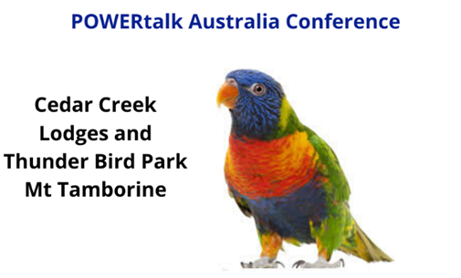  May 21-23 2021 | The POWERtalk Australia Inc AGM will be held by cyber on Friday 22nd May at 7pm.  Please note:  - All Club Mailing with AGM preparation documents will be emailed to Club Presidents and Secretaries.  - Return your club credentials form to the Credentials chair by the due date.  - Please take the time to discuss business items at your club and instruct your delegate.  - Cyber practice session and delegates briefing will be on Friday 15th May at 7pm.  - More information with meeting links will be emailed to Club Presidents, Secretaries and Delegates.  - All members are invited to attend the AGM. Remember, only delegates may vote.

Contests
We’ve had a phenomenal response to calls for competitors in the writing contest. Winners will be announced at the AGM in May and prizes presented at Conference in November. Thank you to all who have submitted their entries.
Congratulations to club open and cosmopolitan speech contest winners who will proceed to the finals which will be held at the 2021 conference.
COVID-19 and Club Meetings – Many clubs have converted to online meetings. Meetup now has a section for online meeting links. Please update your club Meetup listing to include your meeting link, and to remove any cancelled meetings. The Board is working to secure Zoom platform for clubs to use for their meetings. Cyber meetings are open to all members – as such you are welcome join in another club’s meeting.

CAN YOU HELP?
Many hands make light work – we are looking for assistance to keep POWERtalk Australia running smoothly. Here’s what we need.
Webinar presenters – Why not present a 10 minute segment on a subject that fits into any of these themes - communication, concepts, coaching, creating & composing, Clubs & Connections? Get in touch with Janeen Vosper janeen.vosper@speechperfect.com.au
Board Roles – it’s that time of the year when Clubs and Councils are looking for new Board members. Put up your hand and help out – contact your current Club or Council Board and let them know you’re ready to grow.
Newsletter prepared by Mary Wong, Treasurer, 2019-2020

